Amanda Fitzpatrick

Matplotlib Homework Observations

Observation 1:

Based on the graph below, the drug Capomulin had the best impact on tumor volume. The graph shows a decrease in tumor size, whereas the tumor volumes of the other drugs continued to increase over the 45-day treatment.

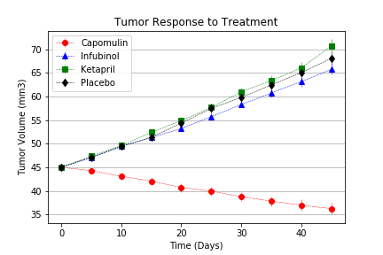

Observation 2:

Based on the graph below of the survival percentage of the mice, Capomulin kept the highest percentage of mice alive. The drug Infubinol seems to have two very drastic drops in survival rate over the 45-day time period and ends up having the smallest percentage of mice survive.

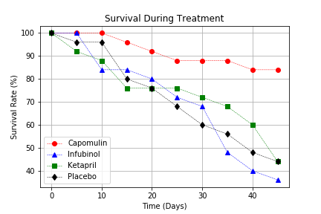

Observation3:

According to the bar graph below of the tumor percent change, Capomulin was the only drug, of the four we have been comparing, that had a reduction in tumor size.

